**Lab Practical #05:**

Study the concept of VLAN using packet tracer.

**Practical Assignment #05:**

1. **Implement the different network structures in VLAN and VLAN trunking. Also check connectivity between them using ping command or PDU utility.**

Implement VLAN:- 1

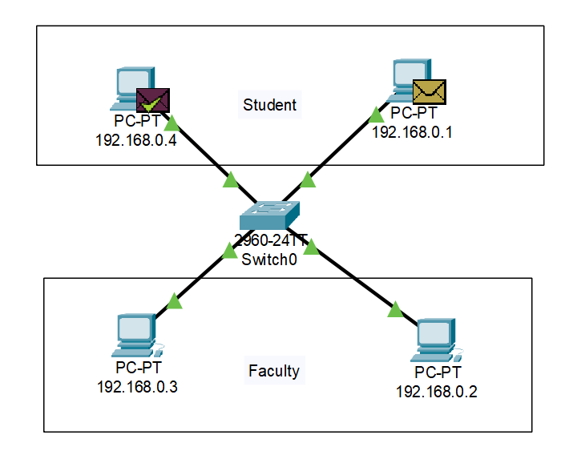

**Step-1: Making a network to connect computer with switch.**

**Step-2: Configure each PC with different IP addresses.**

**Step-3: Configure switch with VLAN Database to give 100 key number of Student and 1000 key number of Faculty.**

**Step-4: Now configuring Fast Ethernet Port with defined VLAN Access who have Student PC or Faculty PC.**

**PDU Details**

**VLAN Database**

**Implement VLAN:- 2**

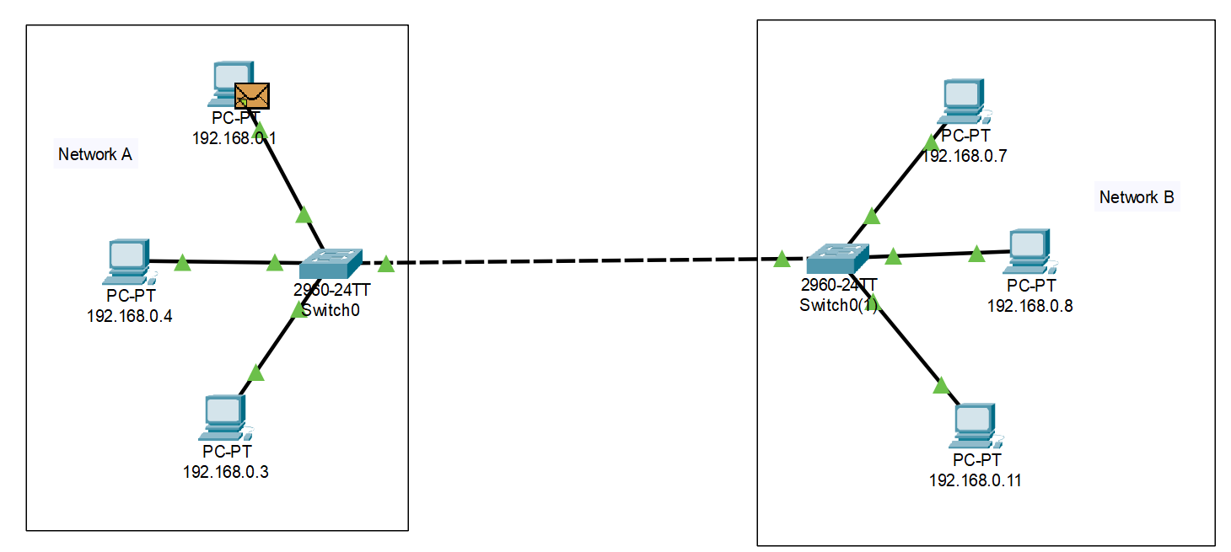

**Implement VLAN:- 3:**

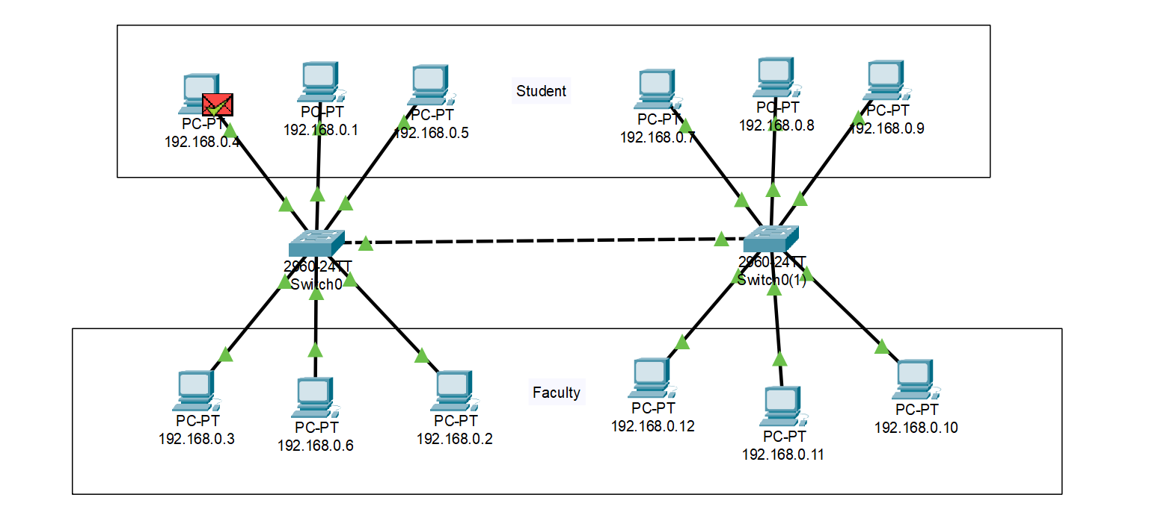

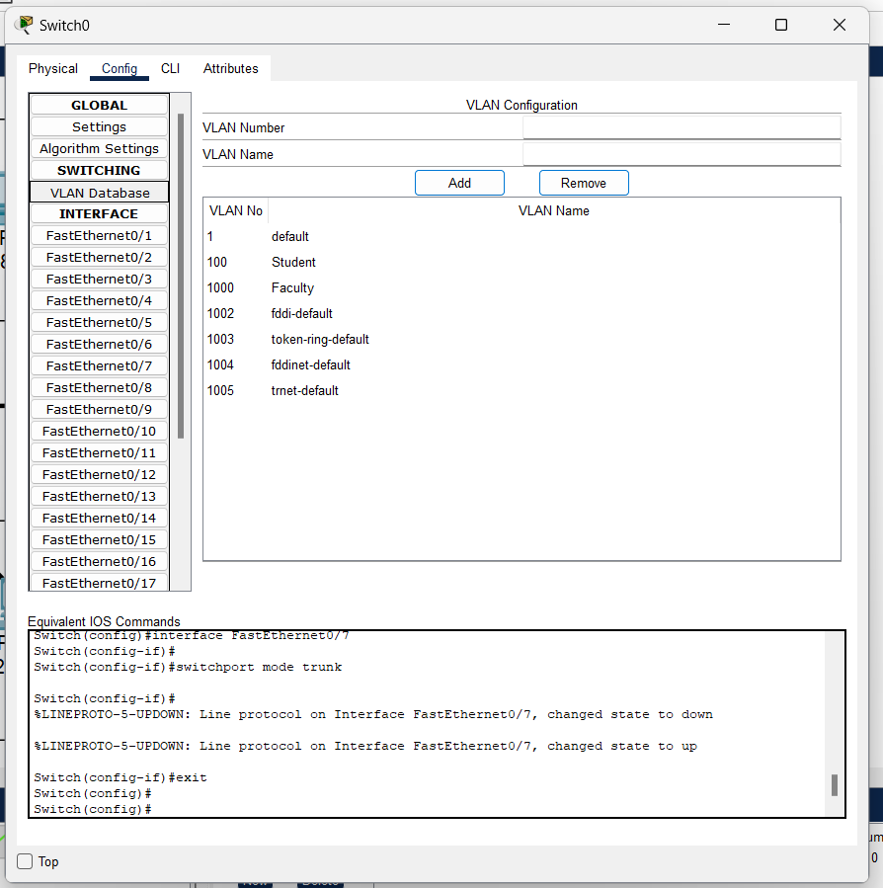

**Implement VLAN – 4**

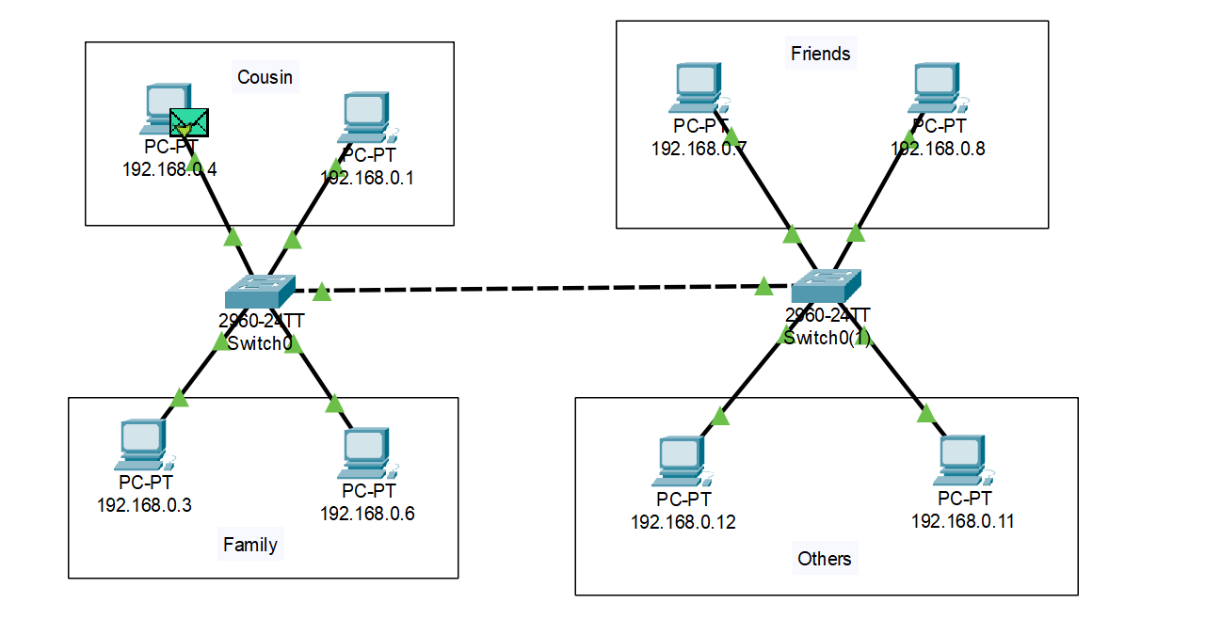

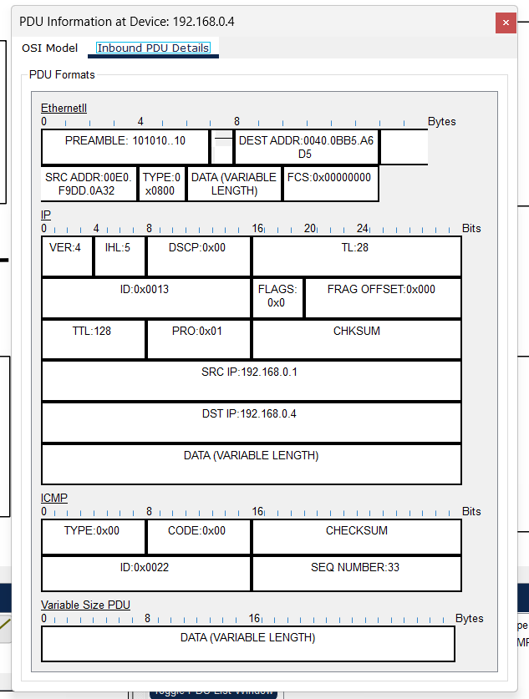

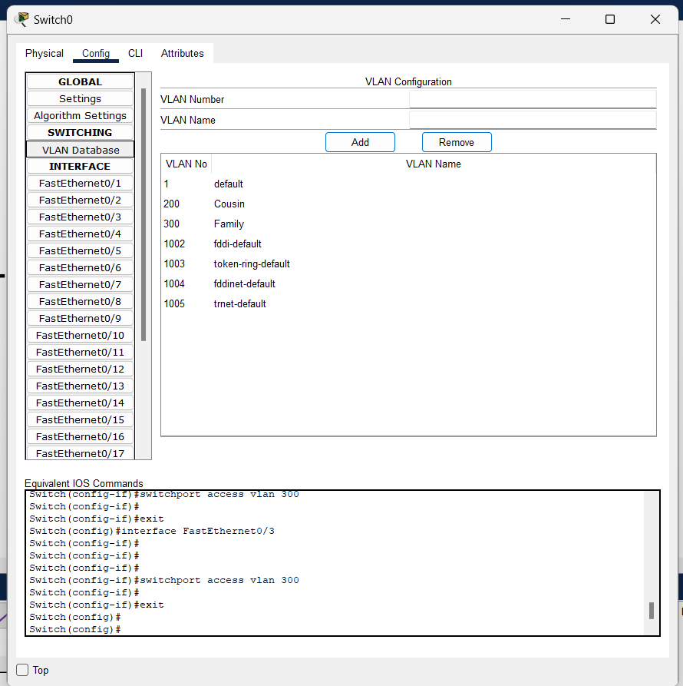

**Instructions:**

1. Different VLANs configuration setup screenshot. (VLAN example given by lab faculty)
2. Write steps to create VLANs in packet tracer.
3. Mention IP address of each pc as label.
4. Ping command or PDU screenshot between two VLANs.